Intermediate, end of unit 10 test Name:_______________________
1. Translate

vzkvétat náplast nástupiště dopravní policista

vagón škála znázornit objetí

vlastnosti zbourat pivovar mistrovský kousek

zámek ovladač žárovka houba na nádobí

2. Translate and describe the objects , say what they are made of and what we use them for
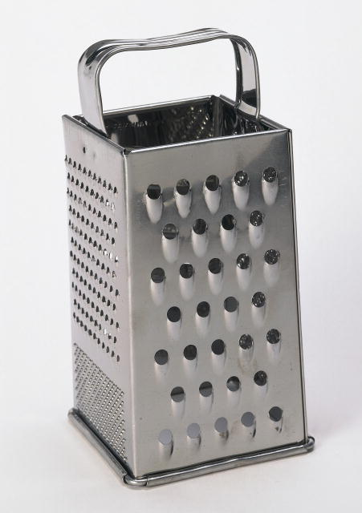
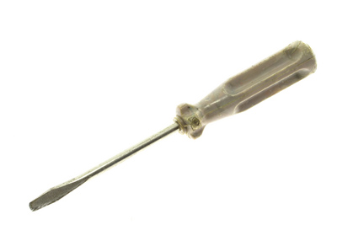

____________ ____________
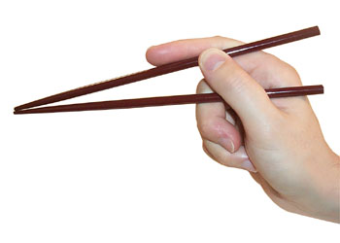
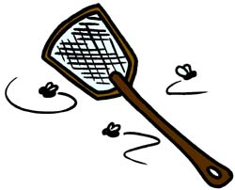

____________ ____________
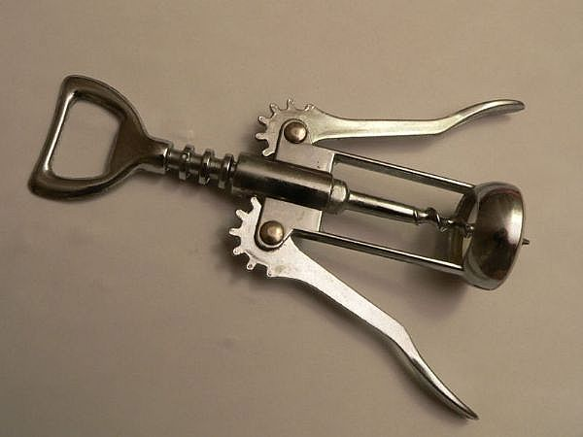
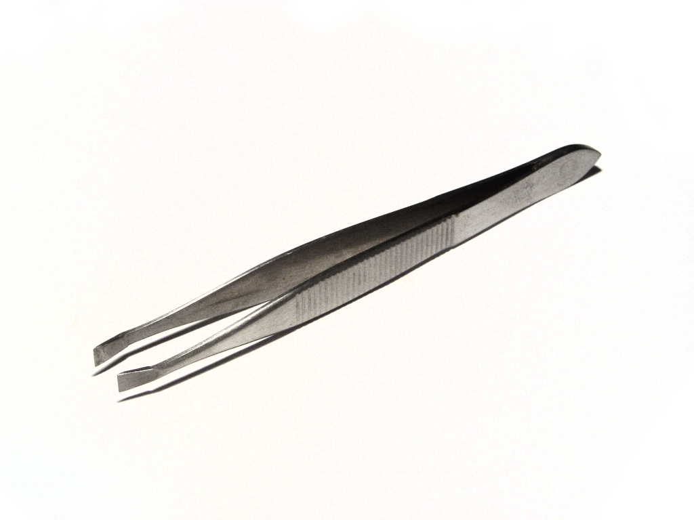

____________ ____________

3. Complete the text with a / an / the / – (no article) or one
My name’s (1) ________ Jessica Wallace. I live on (2) ________ second floor of an apartment building near Fifth Avenue in (3) _______ New York, in (4) ________ USA. I work for (5) ________ English-language school as (6) ________ IT consultant. I haven’t got (7) ________ office of my own. I’m responsible for (8) ________ maintaining our small computer network of (9) ________ nine PCs. There is (10) ________ PC for every three full-time teachers, but I’m (11) ________ only person working in IT.

5. Complete the sentences with the information using reflexive pronouns or each other
1 She loves him and he loves her.
They ___________________________________ .
2 They all help the other students in the class.
In the class, they __________________________________.
3 Kelly’s looking at her reflection in the mirror.
Kelly __________________________________.
4 Ron gets on well with Harry, and Harry gets on well with him.
Ron and Harry __________________________________.
5 I finished the exercise and nobody helped.
I __________________________________.

